Using TaxJar x Shuup
What is Taxjar?
TaxJar is a cloud-based platform that automates the entire sales tax life cycle across all of your sales channels — from calculations and nexus tracking to reporting and filing. Please note that Shuup is not responsible for marketplace taxes. Should there be any questions or concerns regarding marketplace taxes, tax laws, or relating matters, please visit TaxJar's website or reach out to TaxJar's customer service team.

Why use Taxjar x Shuup?
Once a vendor retrieves their API key from Taxjar and inputs it into their Shuup back-end admin panel, all of the teax classes needed will get imported from Taxjar directly into Shuup. These tax classes can then be used on vendor products. This automates the tax life cycle process for your admin and vendors.
Which plan should I select in Taxjar?
Taxjar requires a Professional (Pro) Plan or above in order to use their API integration. More information on Taxjar plan pricing can be located here: https://www.taxjar.com/pricing

How to Retrieve TaxJar API Credentials

- As a vendor, navigate to : https://taxjar.grsm.io/9lw03mklci3v. Your screen should look something like this. Click on the “Login” button to create a new account with TaxJar.

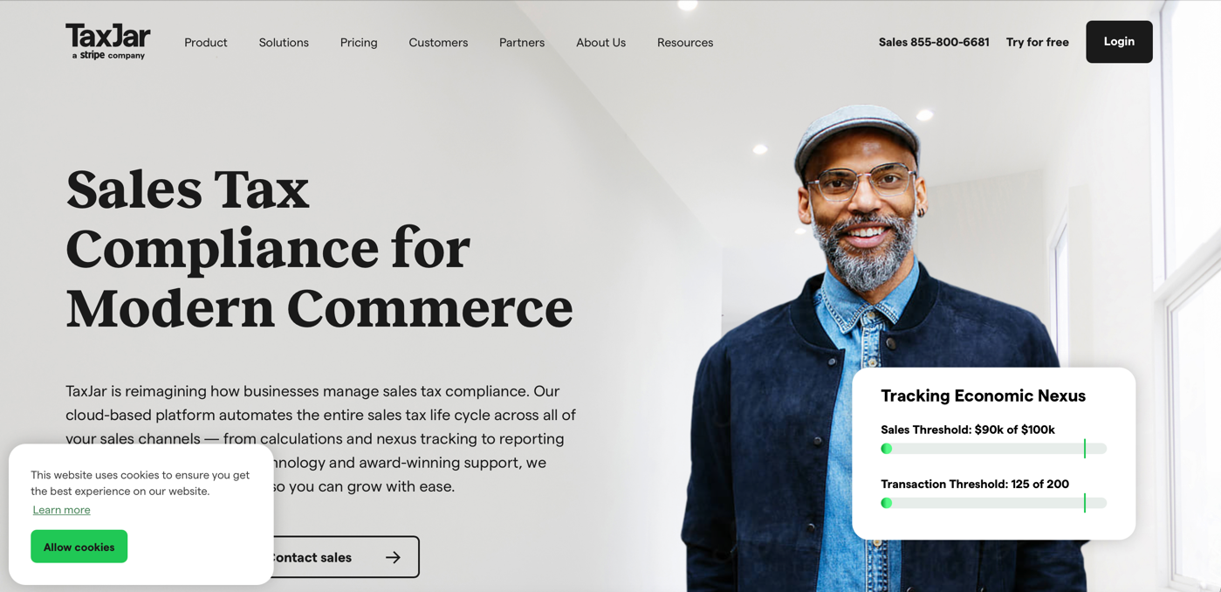
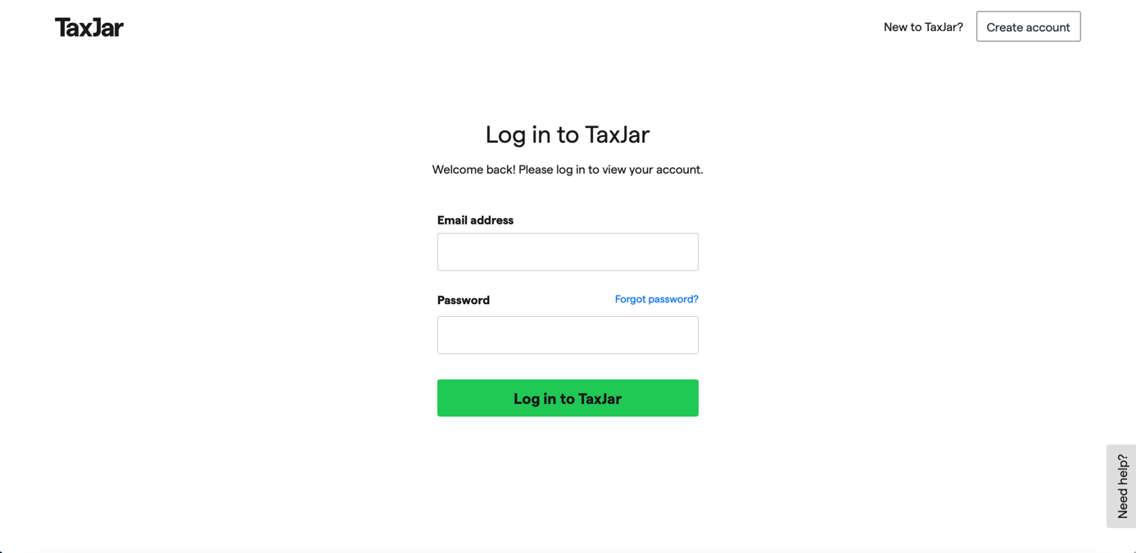
- Once you create an account, you will to complete 3 steps to complete sign-up with Taxjar. You will be asked information about your business, your data sources, and to begin importing information. For Step #2 (Select Your Data Sources), you will need to select the second option called “API Integration.”

- Once selected and all 3 steps have been completed, you should be re-directed to your Dashboard as it appears below. In order to retrieve your API key you must select the green “Connect Integration” button, or use the account drop-down menu in the top-left corner to select “TaxJar API.”
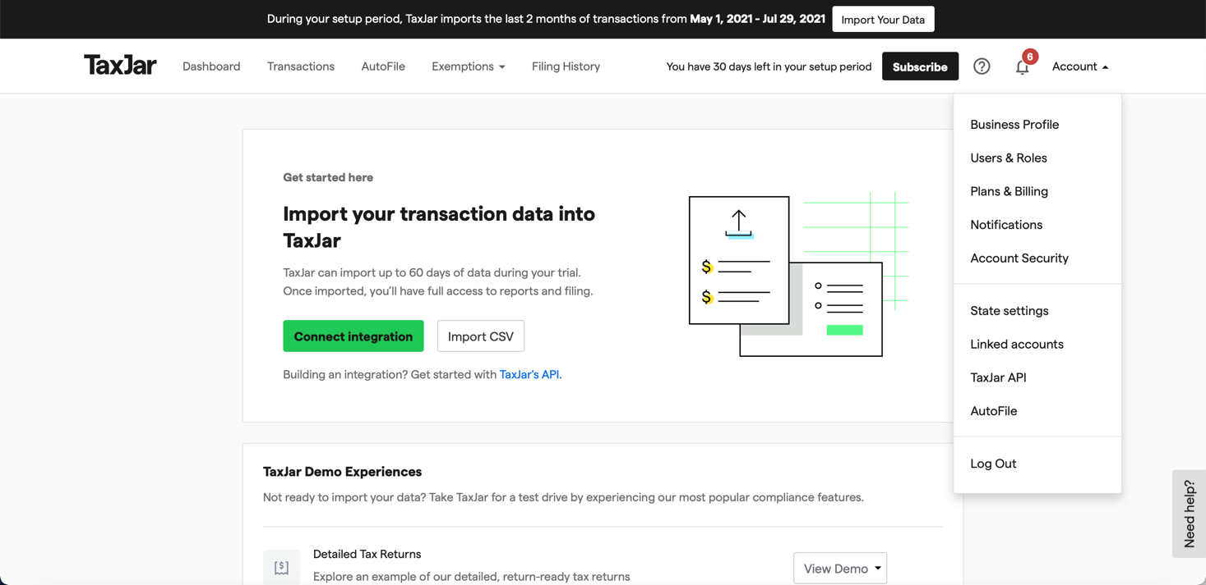
- After you have navigated to the TaxJar API Token page, you will copy the “Live Token” and paste this into Shuup’s back-end. To input the API Token into Shuup, navigate to the “Settings” tab and then select “Taxjar.”

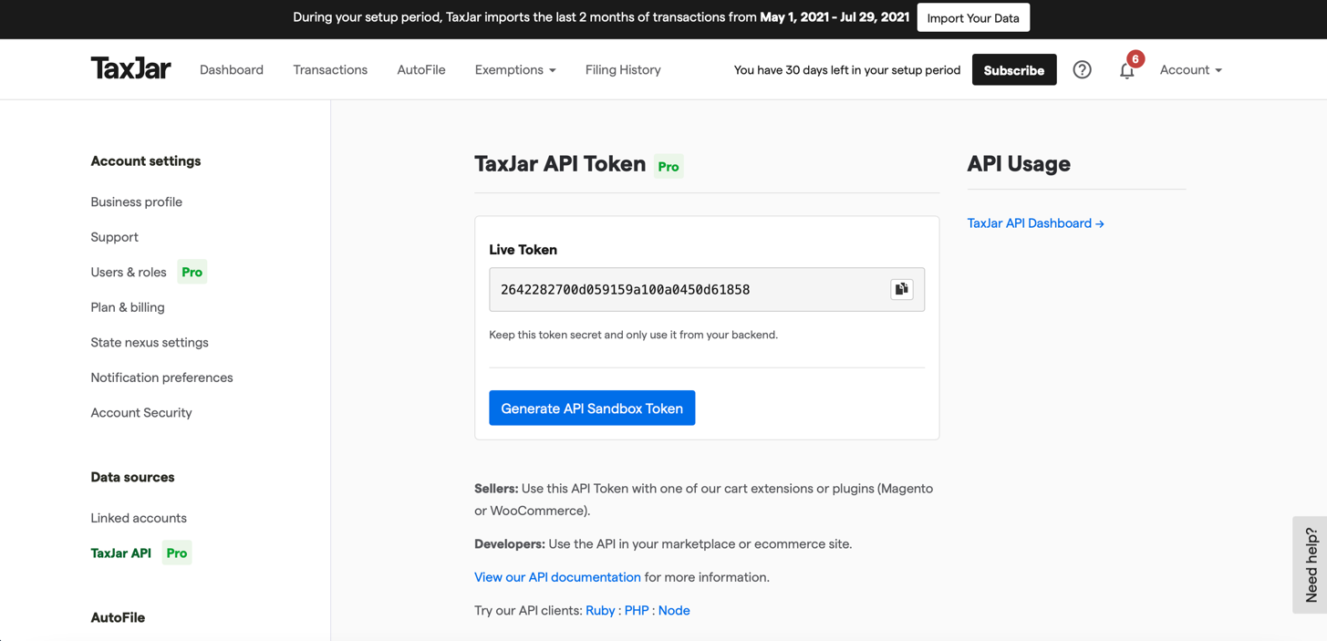

- Read through all documentation and then select the “TaxJar Connect” Tab. Input your API Token into the field. Be sure to de-select the “Sandbox Token” box if you are using the live API key.
